**A3: User Interface Prototype**

This document has the purpose of showcasing the design of and user interaction with the BidBay web application, through the use of page mockups, a sitemap and storyboards.

**1. Interface and common features**

The user-facing mockup for BidBay was built using the Bootstrap framework. [Flatly](https://bootswatch.com/flatly/) was also used to set a common color scheme and component design across all pages.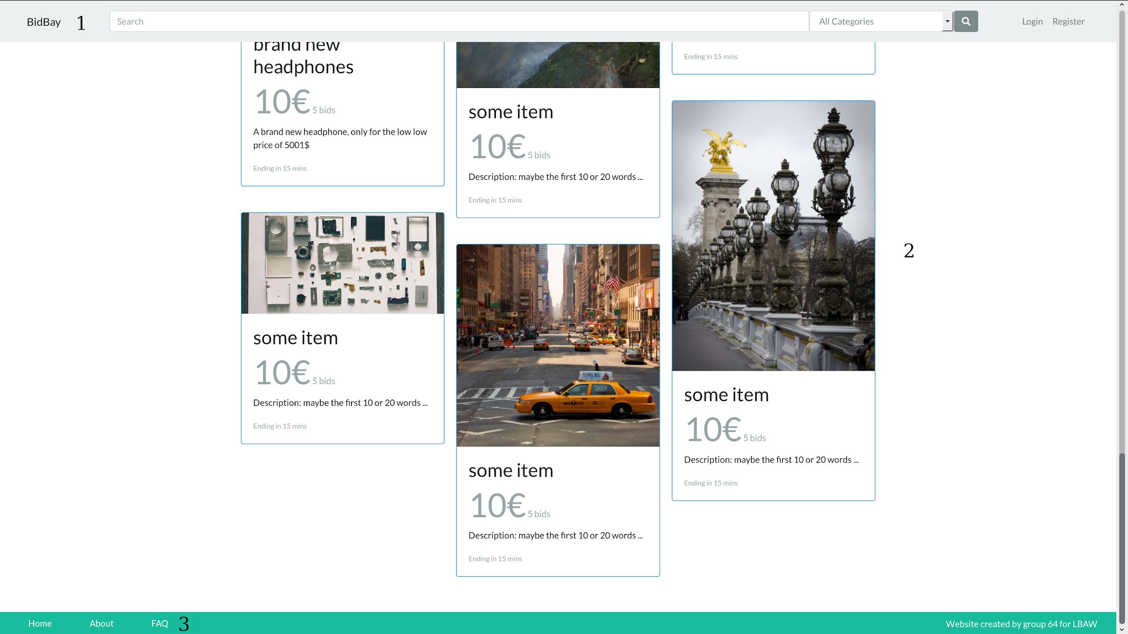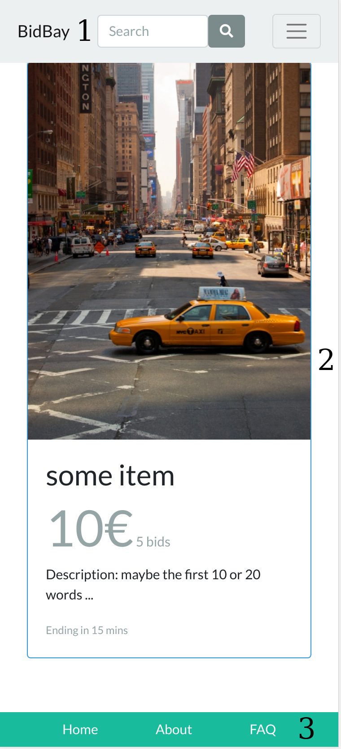

Figure 1: common elements in our website (2 cropped screenshots which show the top and bottom of the home page.

1. Header: The header stays on top of the page when the user scrolls down. It contains the logo, the search bar for auctions with specific categories and user authentication which contains the login and register page or a dropdown for the user.
2. Content which changes depending on the page.
3. Footer: Is at the bottom of the page and contains some navigation links (home page, about and FAQ) and a “trademark”

All the pages have 1. and 3. which are the same for all pages.

We have added support for various screen sizes for our pages, from mobile, to tablet and desktop.

All pages share a common color scheme and component design.

**2. Sitemap**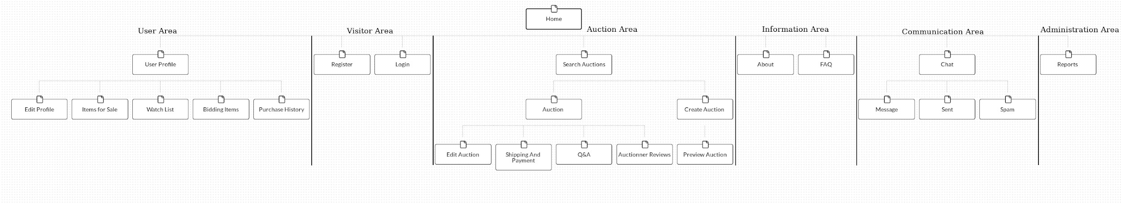

[Figure 2](https://i.imgur.com/I3SLahX.png): Sitemap for the website.

**3. Storyboards**

Here are included the main storyboards for our website, illustrated with screenshots and wireflows.

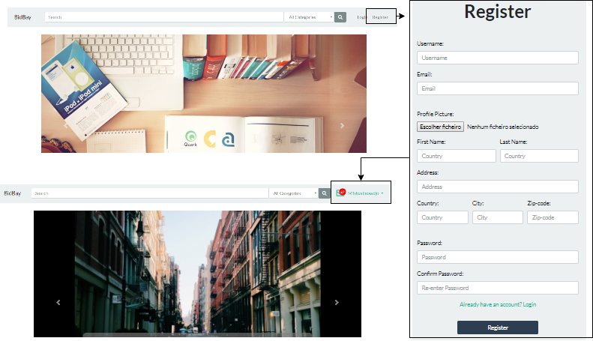Figure 3: Wireflow centered on a user’s registry

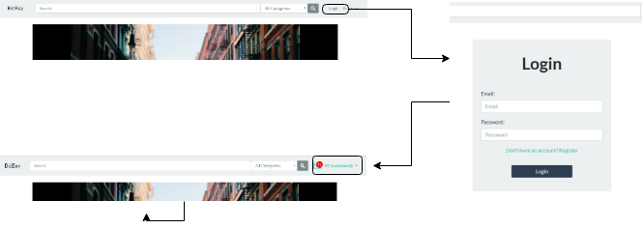

Figure 4: Wireflow centered on a user’s login

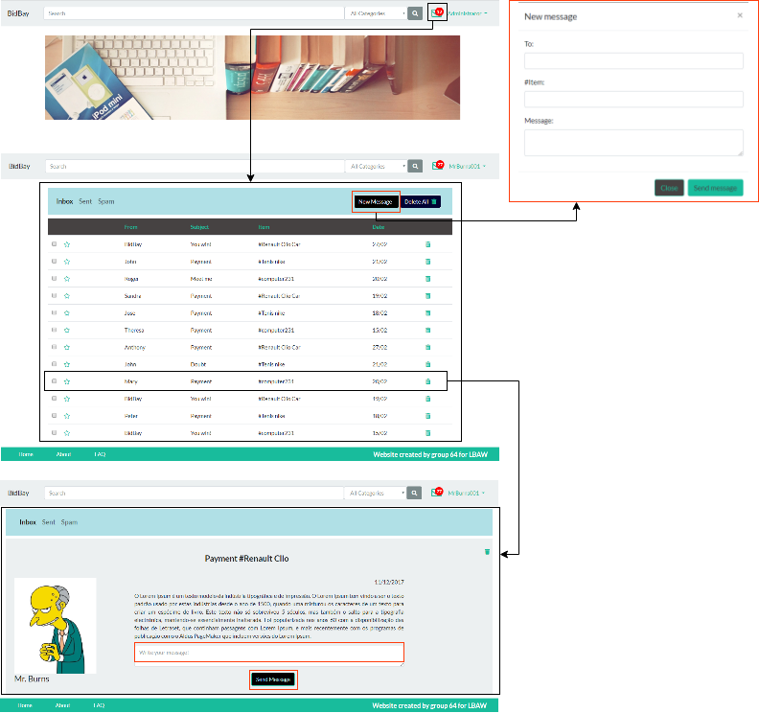

Figure 5: Wireflow centered on a user’s message view - create new message and answer to a message from another user - which is also used to discuss and finalize winning/selling auctions

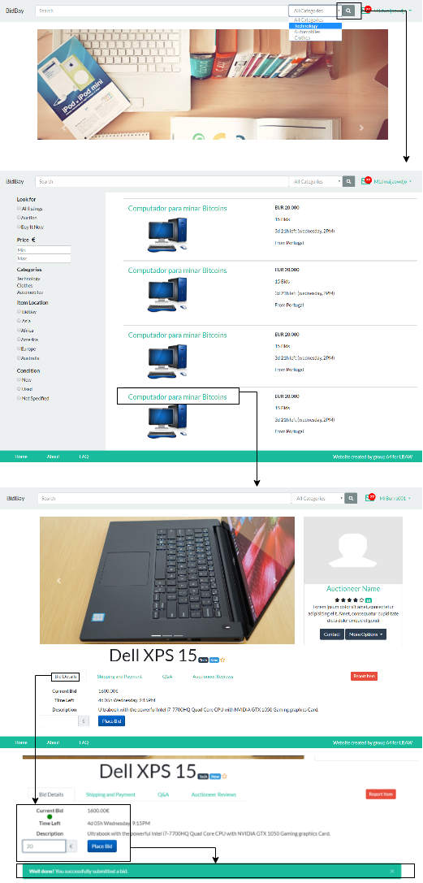

Figure 6: Wireflow centered on user’s bidding

Figure 7: Wireflow centered on user’s auction’s creation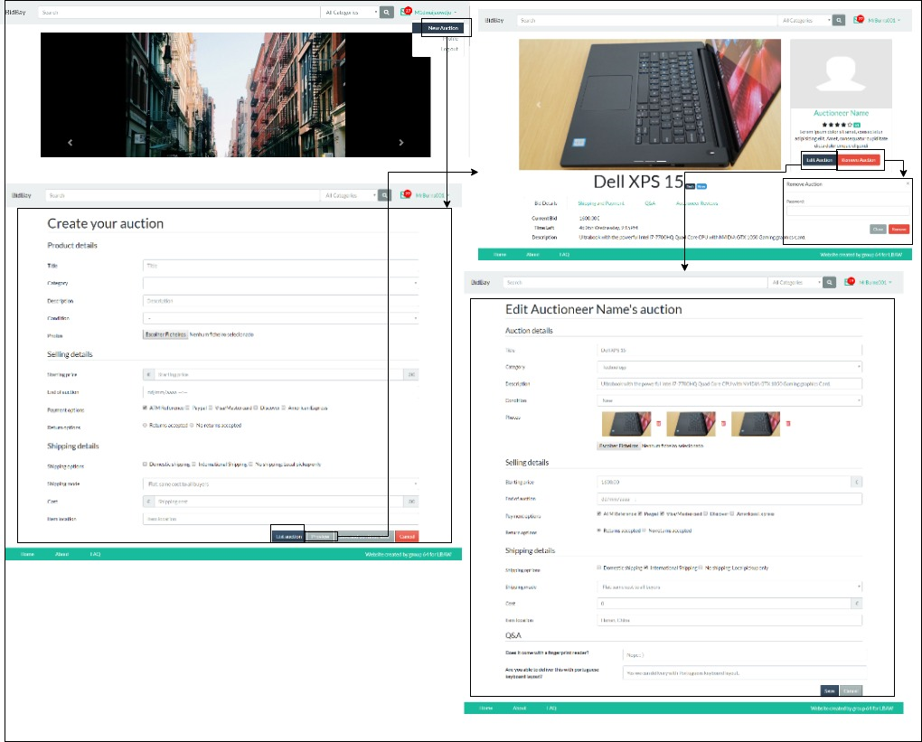

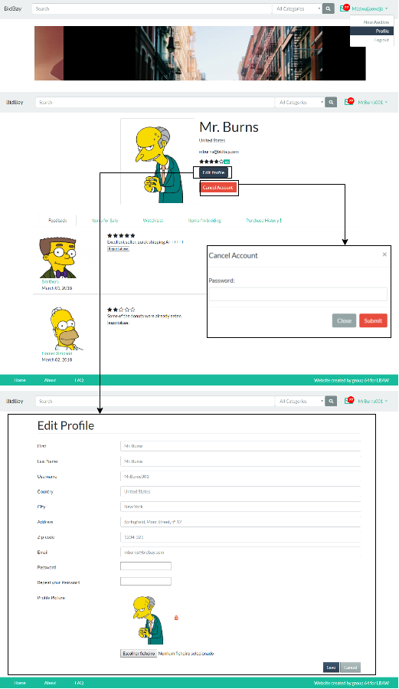

Figure 8: Wireflow centered on user’s profile - Edit Profile and Cancel Account

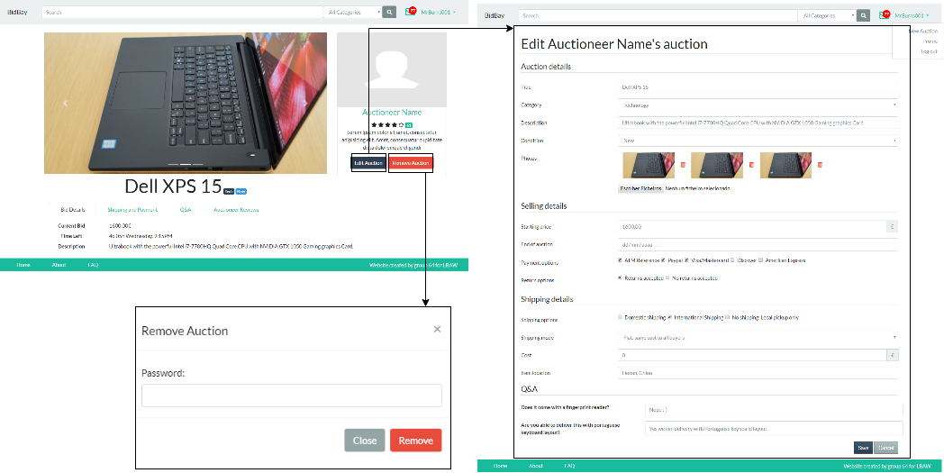Figure 9: Wireflow centered on auctioneer’s chance to edit or cancel an auction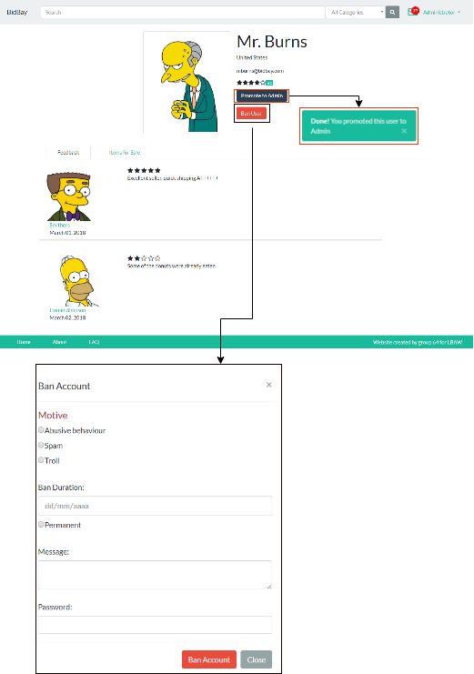

Figure 10: Wireflow centered on administrator’s chance to promote an user to administrator or ban his account

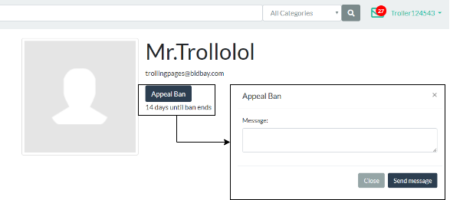

Figure 11: Wireflow centered on banned user’s profile - Appeal Ban by sending a message to the administration

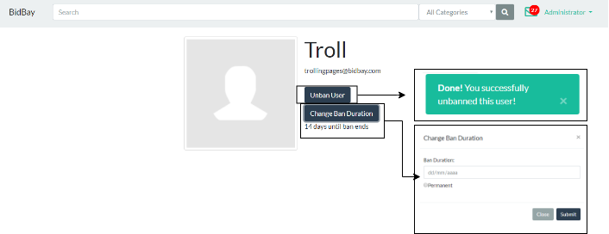

Figure 12: Wireflow centered on administrator’s chance to unban an user or change his ban duration

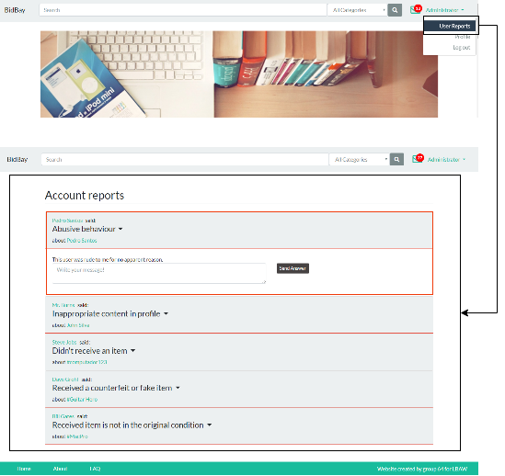

Figure 13: Wireflow centered on administrator’s chance to view and answer to user’s reports

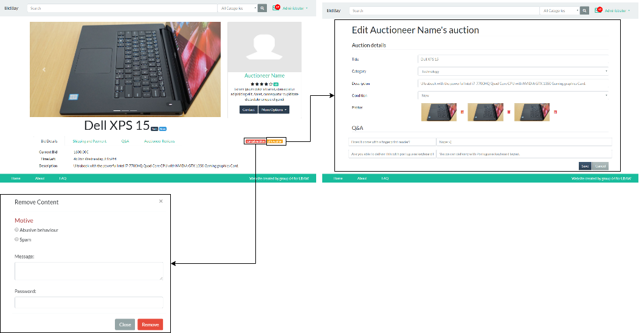

Figure 14: Wireflow centered on administrator’s chance cancel or edit user’s auctions

**4. Interfaces**  
   
This sections is filled with screenshots with desktop version on the left and mobile versions on the right. All of the screenshots are for the full page except the the home page which is too long to fit. The mobile screenshots here are taken using the iPhone 8 screen configuration.

**UI01: Home Page**

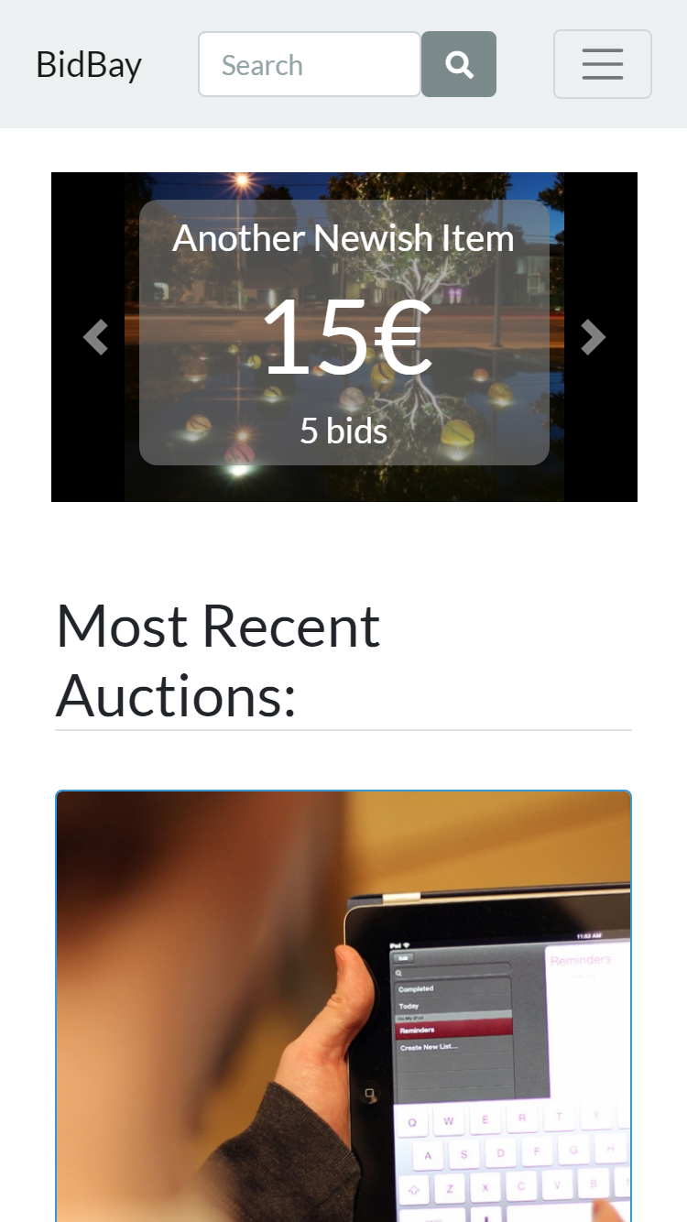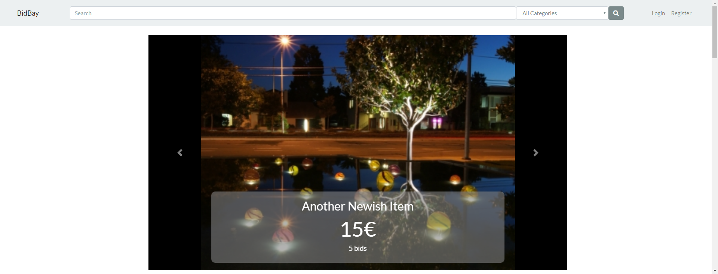

Figure 11: [Home Page](https://afonsobspinto.github.io/lbaw1764/home/landing_page.html) (the screenshots is only for the view from a device and not the full size since Its too long)

**UI02: About**  
Figure 12: [About page](https://afonsobspinto.github.io/lbaw1764/about.html)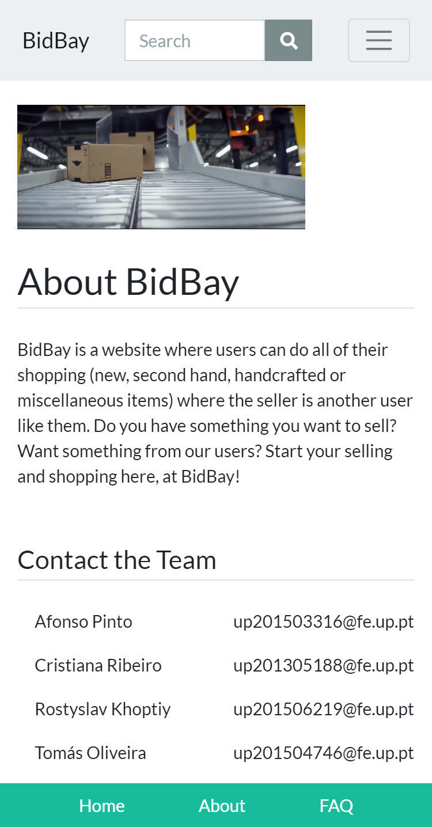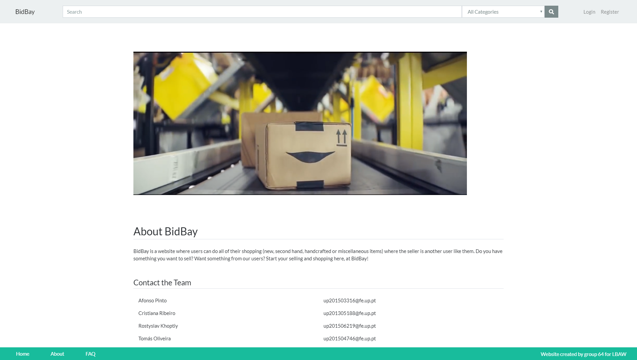

**UI03: Frequently Asked Questions (FAQ)**

Figure 13: [FAQ page](https://afonsobspinto.github.io/lbaw1764/FAQ.html)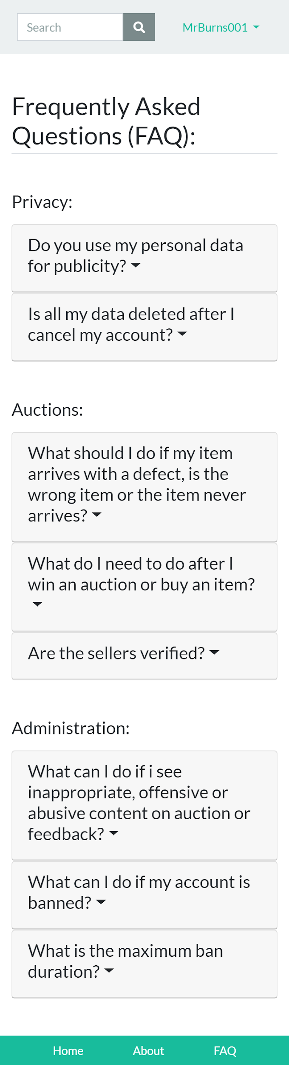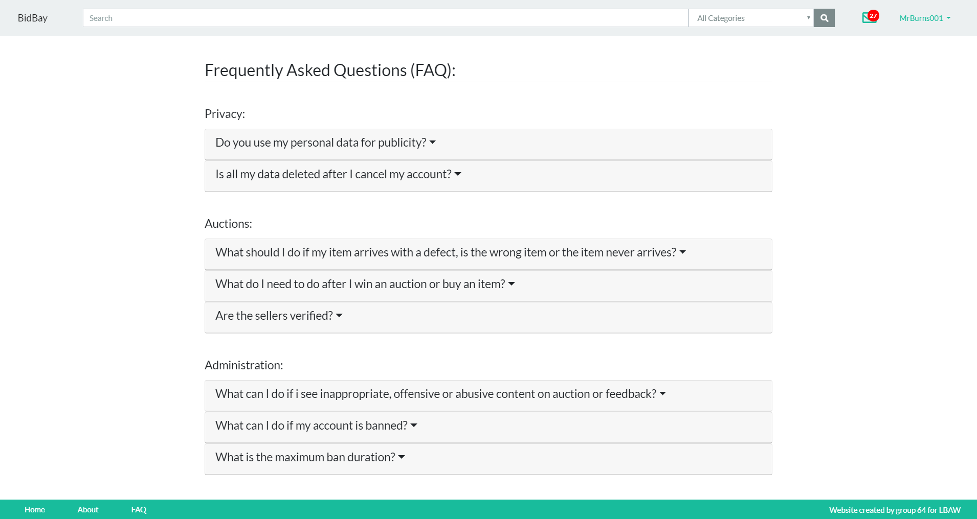

**UI04: Login**

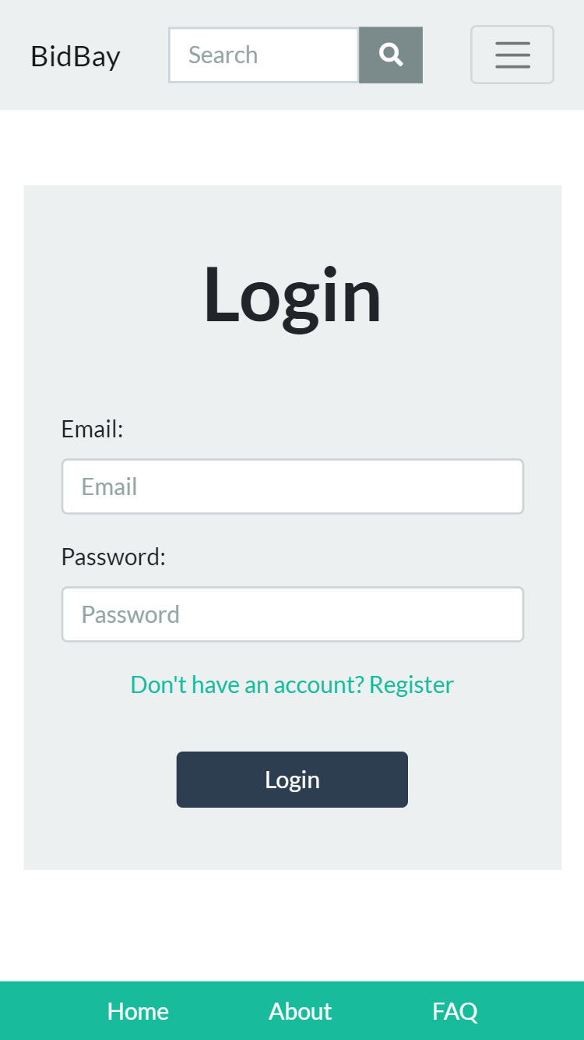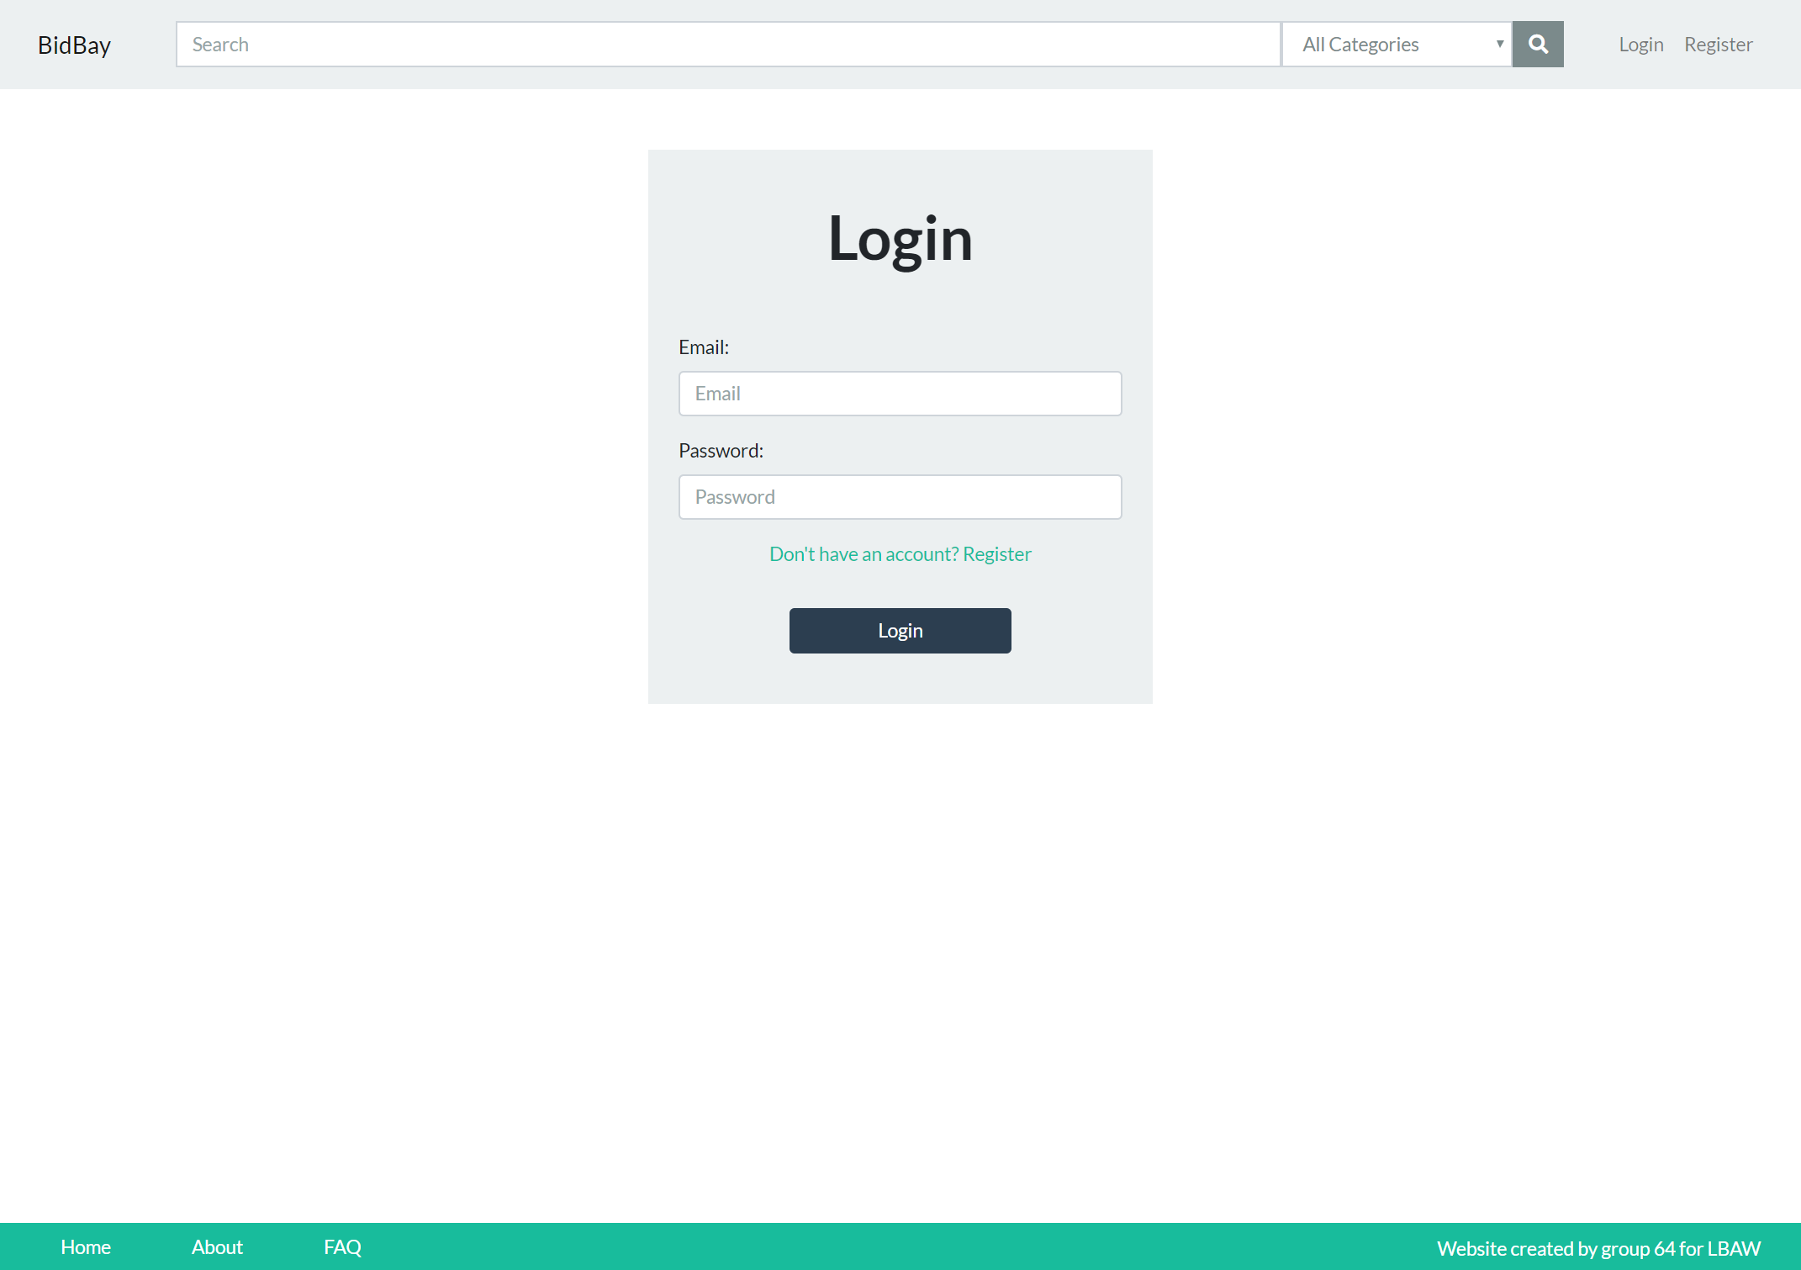

Figure 14: [Login page](https://afonsobspinto.github.io/lbaw1764/login.html)

**UI05: Register**

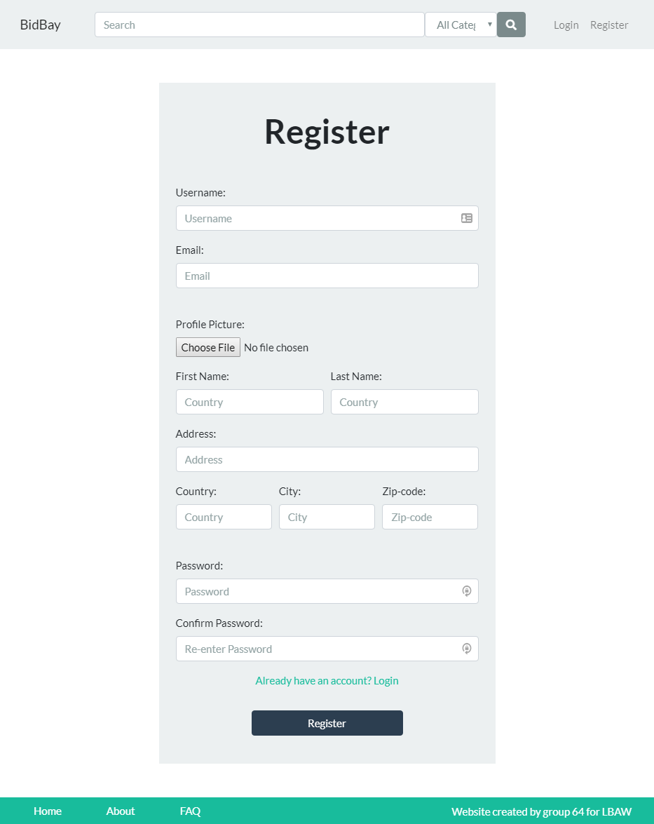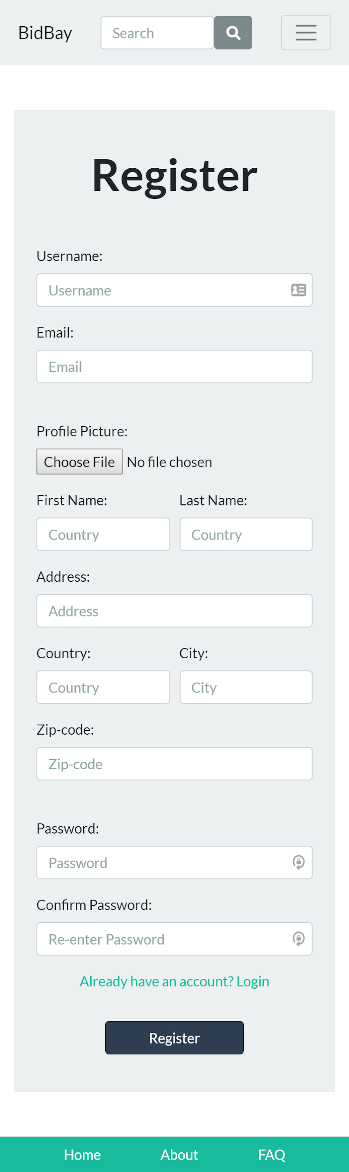

Figure 15: [Register page](https://afonsobspinto.github.io/lbaw1764/register.html)

**UI06: Profile**  
 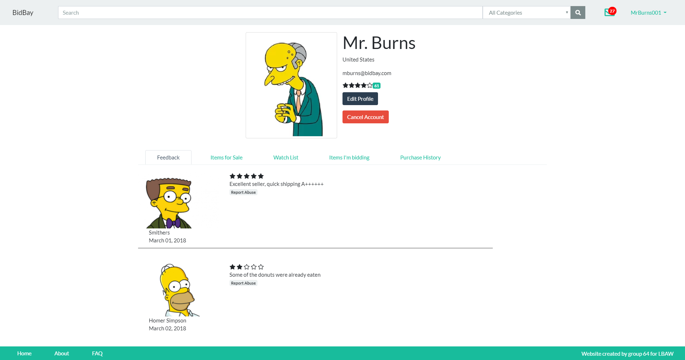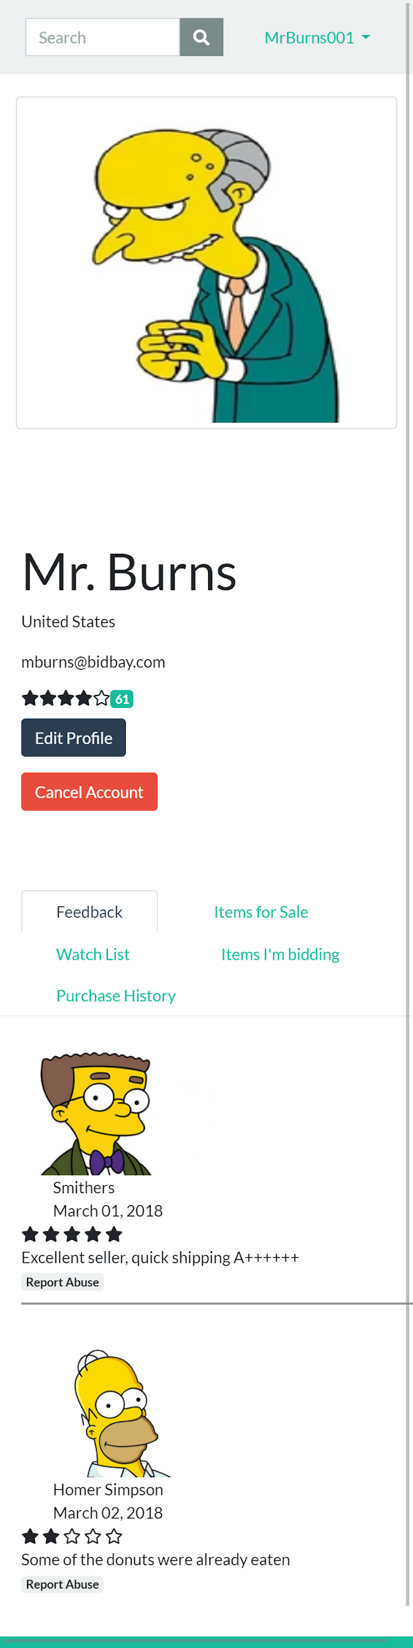

Figure 16: [Profile page](https://afonsobspinto.github.io/lbaw1764/profile/profile_asUser.html)

**UI07: Chat**

Figure 17: [Chat page](https://afonsobspinto.github.io/lbaw1764/chat.html)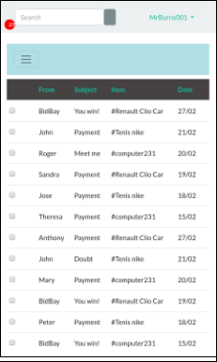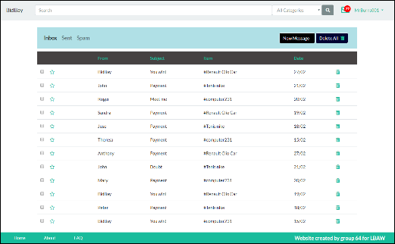

**UI08: Message**

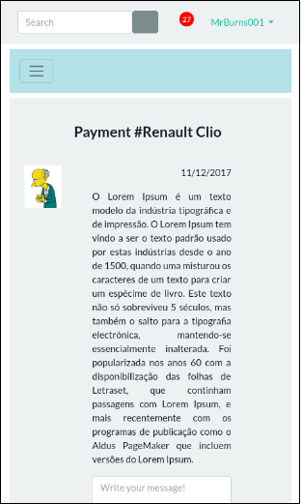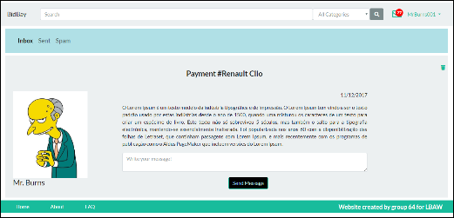

Figure 18: [Message page](https://afonsobspinto.github.io/lbaw1764/message.html)

**UI09: Search**

Figure 19: [Search page](https://afonsobspinto.github.io/lbaw1764/advanced_search.html)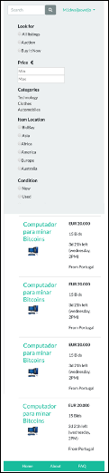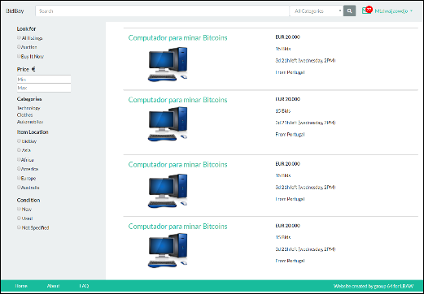

**UI10: Report**

Figure 20: [Report page](https://afonsobspinto.github.io/lbaw1764/report.html)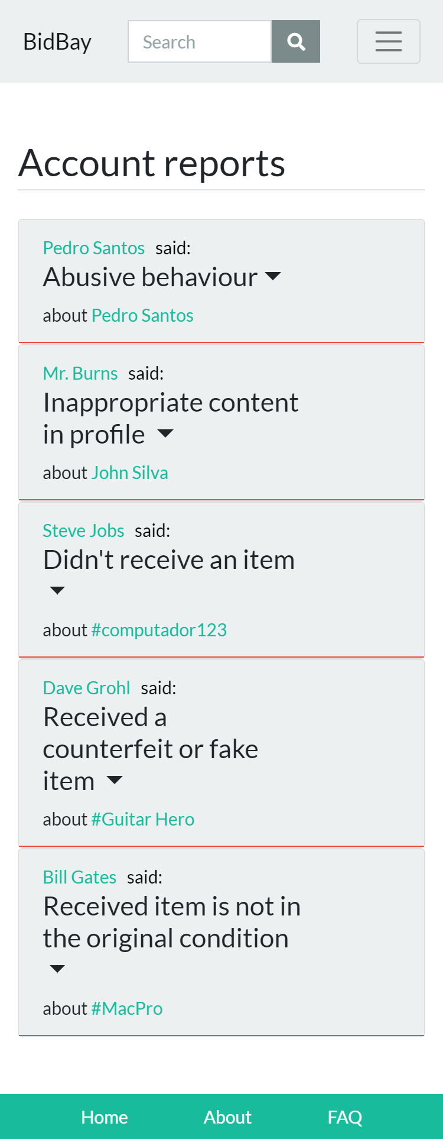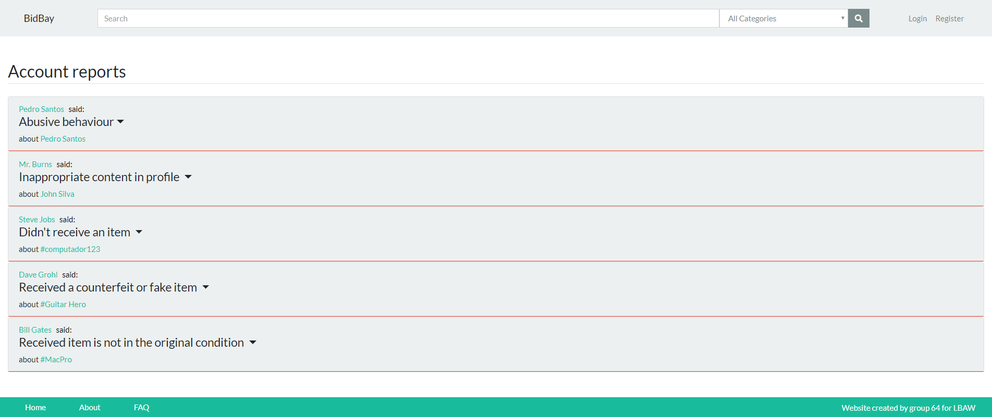

**UI11: Auction**

Figure 21: [Auction page](https://afonsobspinto.github.io/lbaw1764/auction/auction.html)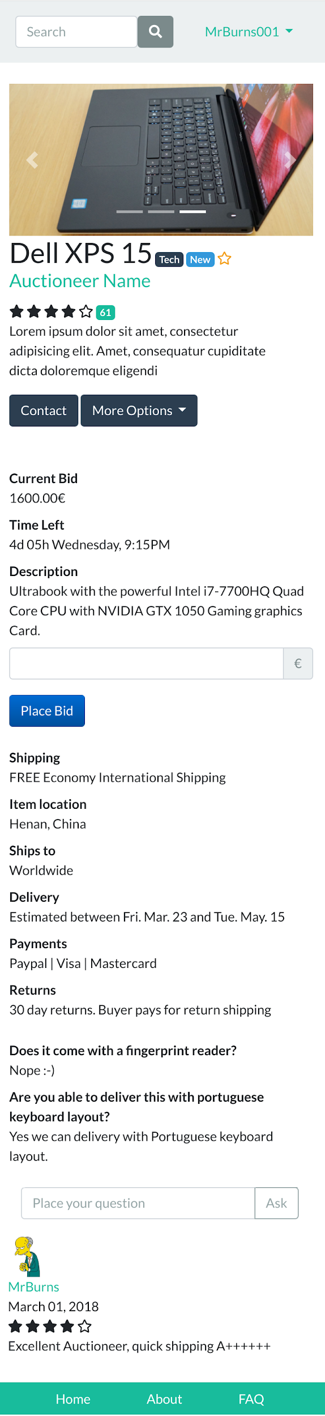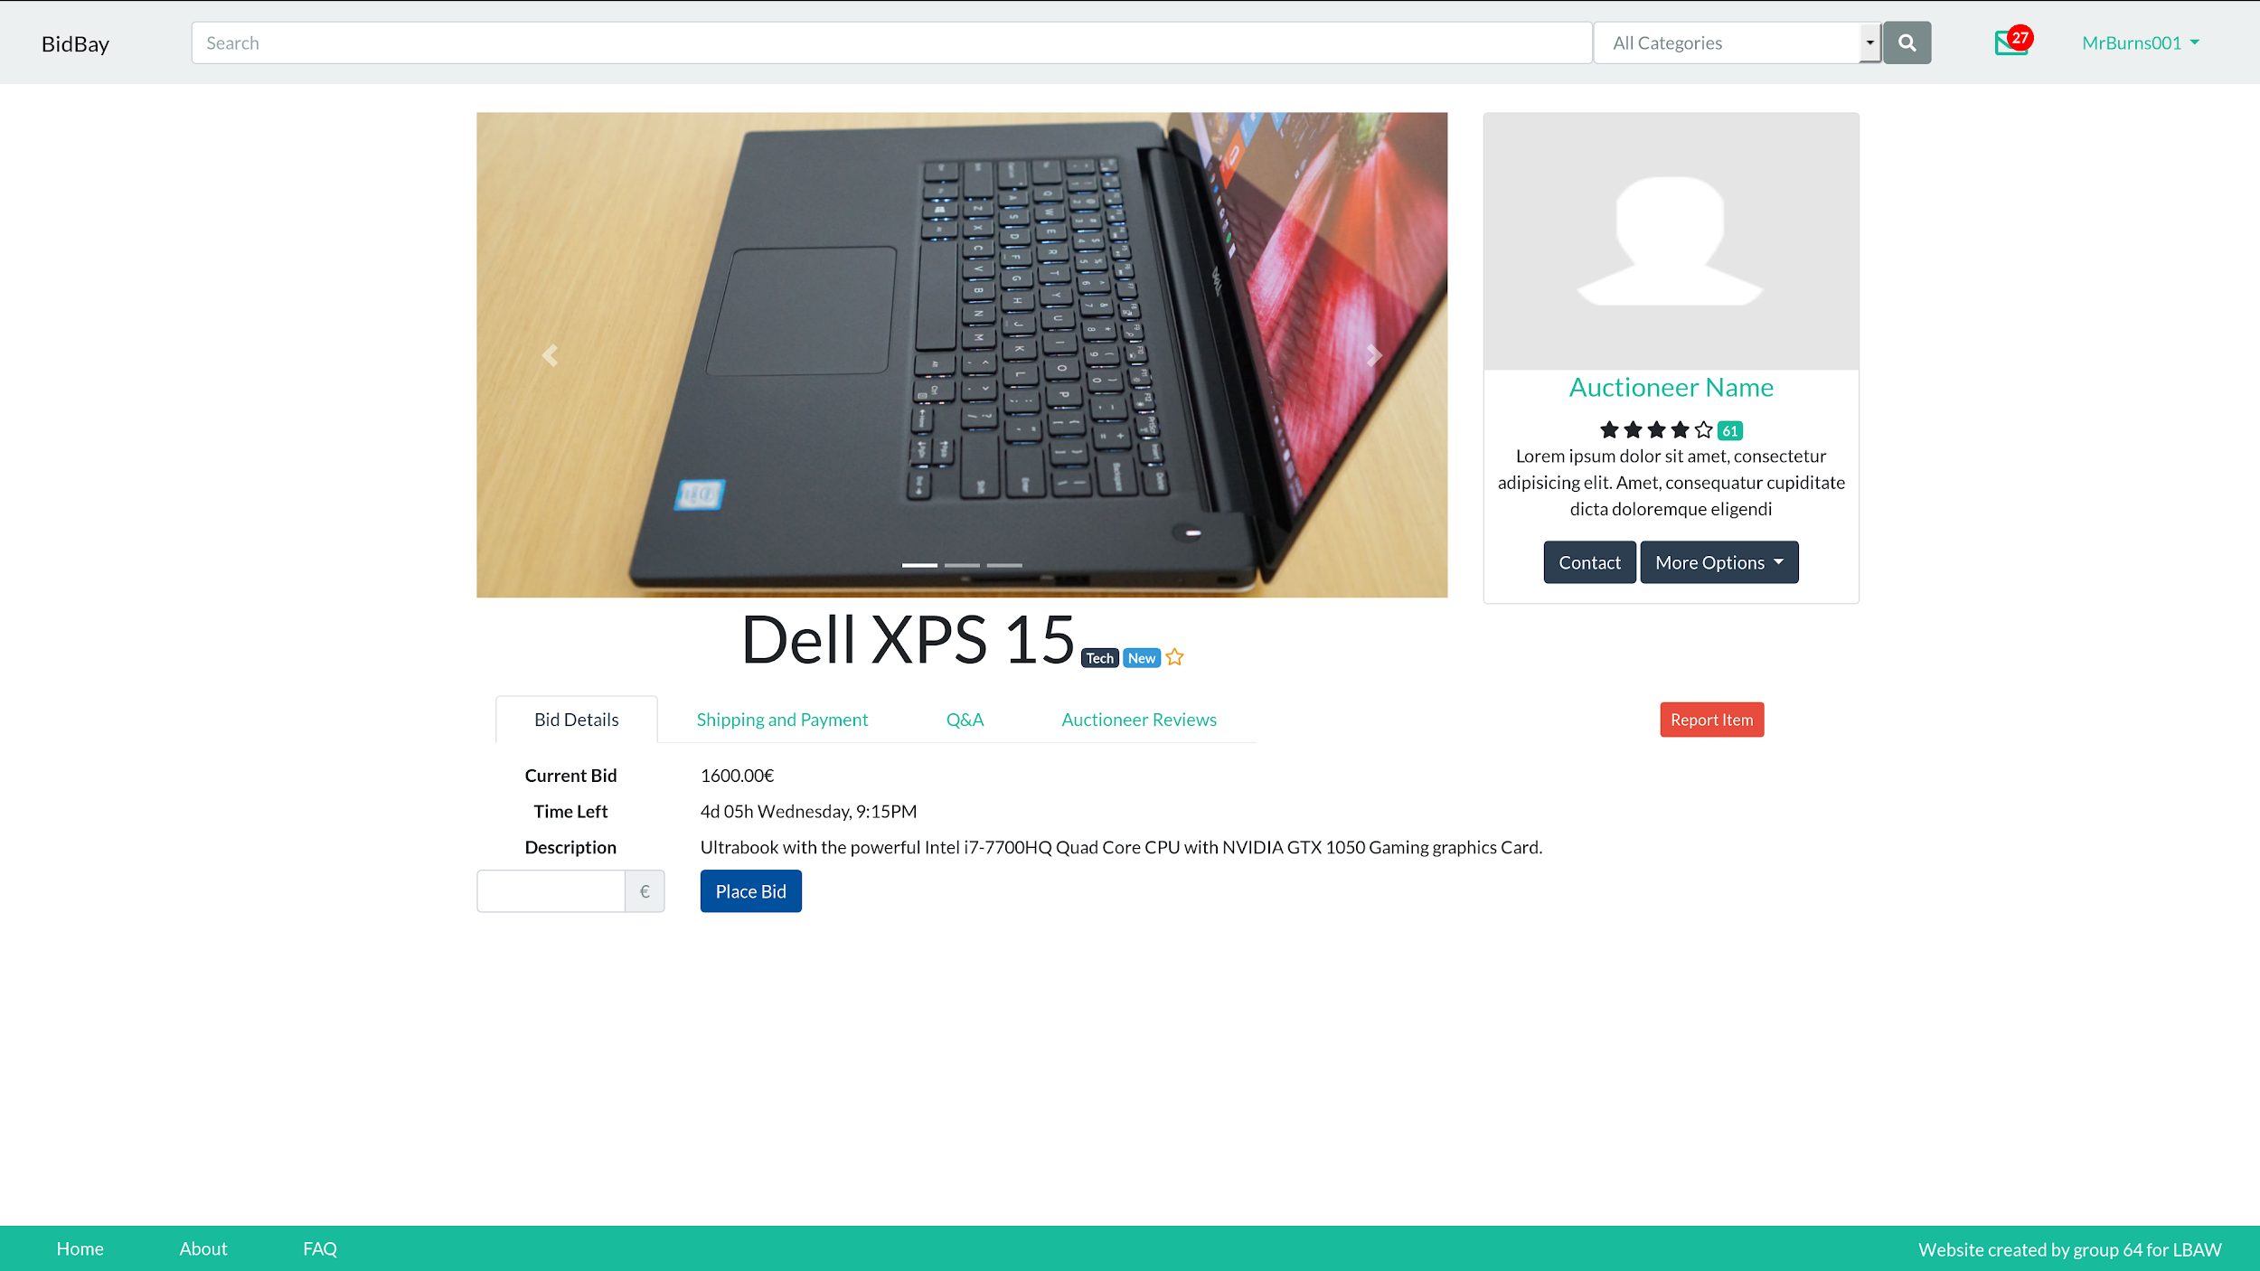

**UI12: Create Auction**

Figure 22: [Create Auction Page](https://afonsobspinto.github.io/lbaw1764/sell_page.html)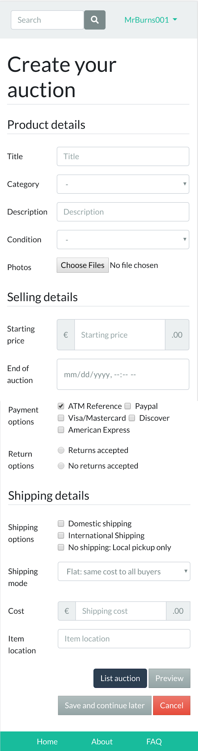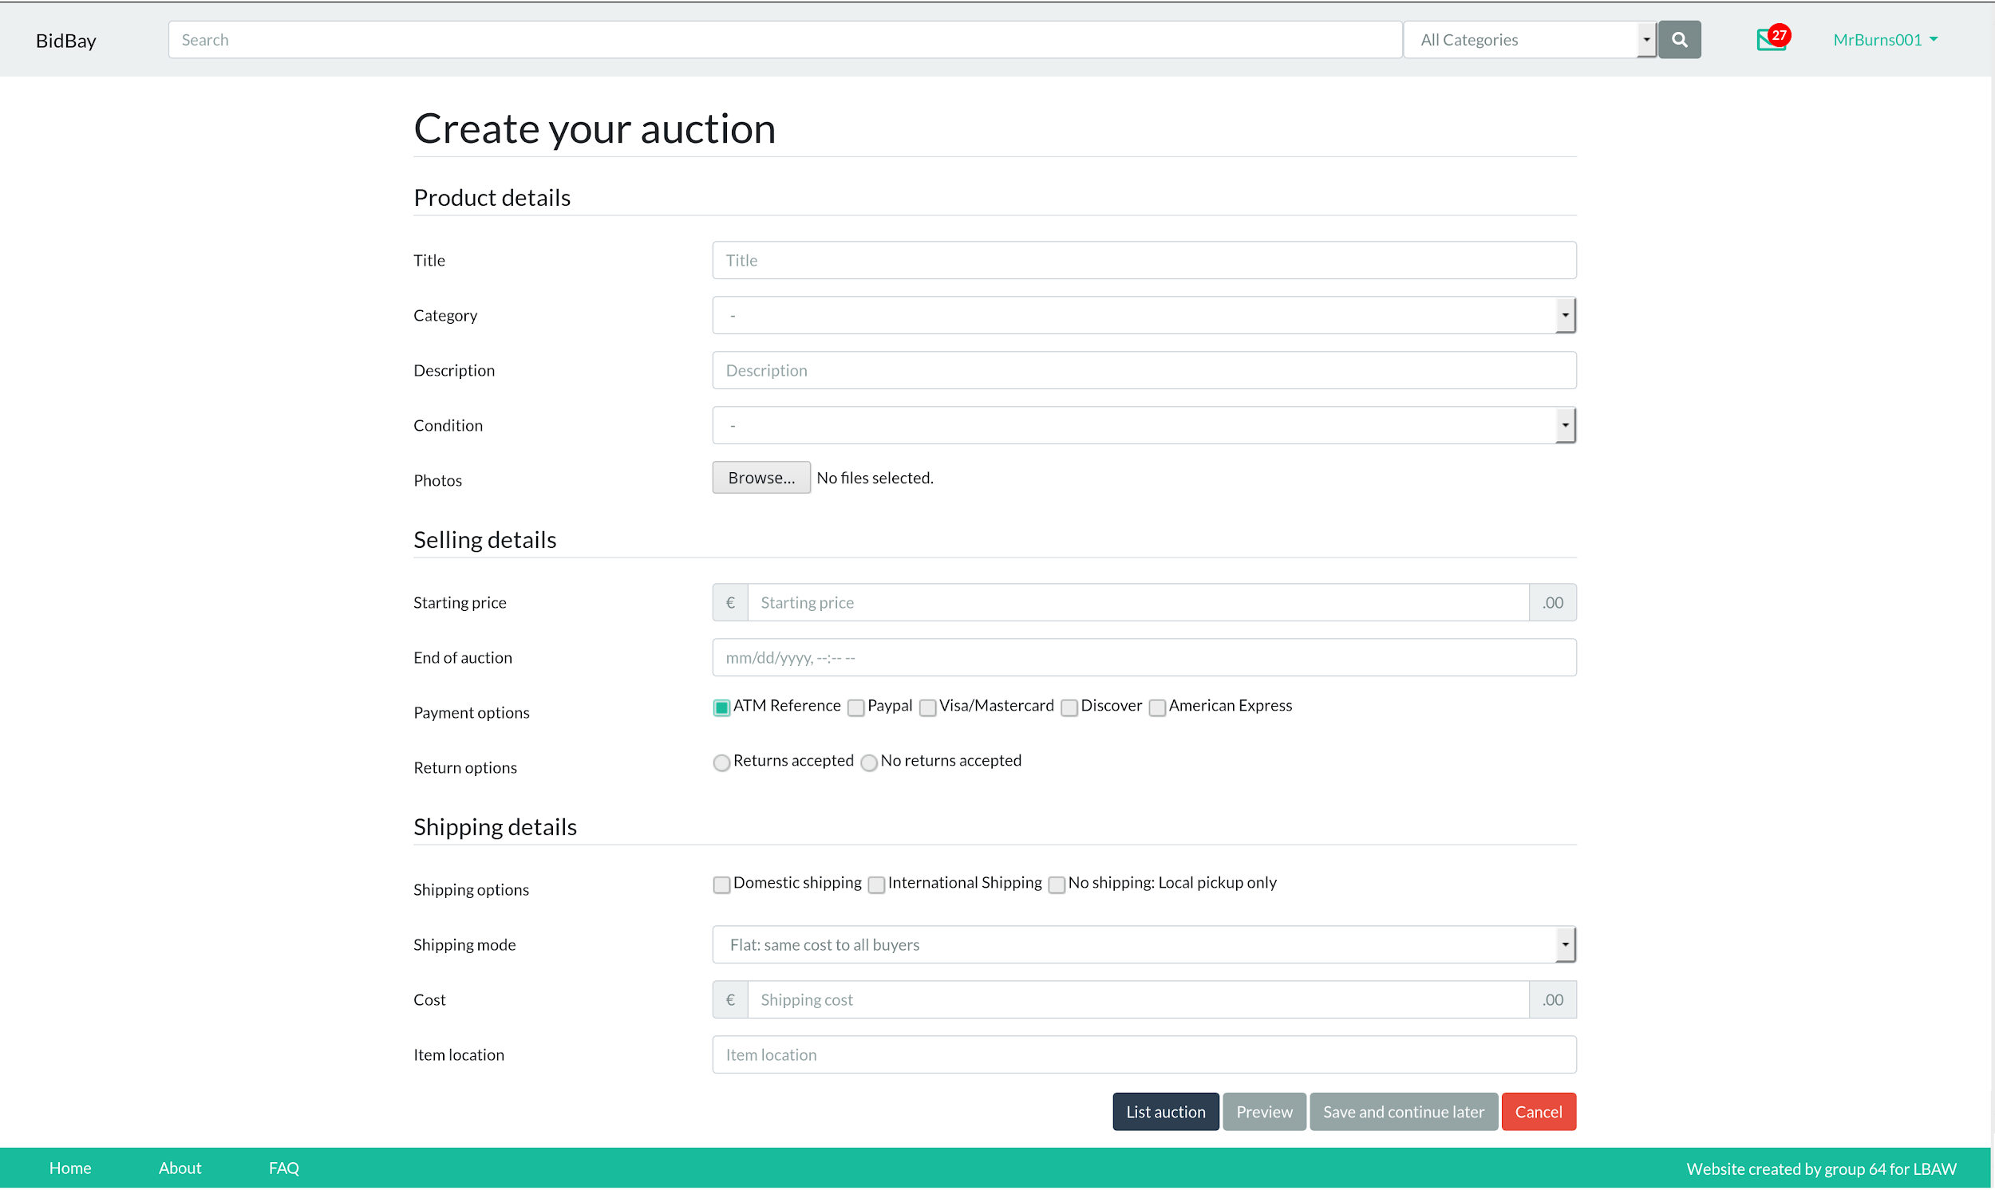

**Revision history**  
   
Changes made to the first submission:

1. Improve auction page.
2. Add edit auction view.
3. Fix product preview.
4. Change squared icons to rounded icons.
5. Highlight price over bids.
6. Fix about page.
7. Fix profile pages.
8. Add edit profile view.
9. Improve register.
10. Improve search page.
11. Rename products to auctions.
12. Fix broken links
13. New sitemap
14. New storyboards
15. Add border on pdf images
16. Re-taken register page screenshot

GROUP1764, 13/03/2018  
   
Afonso Bernardino da Silva Pinto, up201503316@fe.up.pt  
Cristiana Maria Monteiro Ribeiro, up201305188@fe.up.pt  
Rostyslav Khoptiy, up201506219@fe.up.pt  
Tomás Sousa Oliveira, up201504746@fe.up.pt